

SCHOOL OF APPLIED SCIENCE
A Mini Project Report

On

“ONLINE ASSESSMENT SYSTEM”

Submitted partial fulfillment of requirement for the III semester

Master of Computer Applications (MCA)
Specialization in Artificial Intelligence & Machine Learning

Submitted By
Kamalakanta Behera
24SUPMCAGL037

Under the Guidance of
Mrs. Harshitha E
Assistant Professor
School of Applied Science, SNPSU

SAPTHAGIRI NPS UNIVERSITY
#14/5, Chikkasandra, Hesarghatta Main Road, Bengaluru – 560057



SCHOOL OF APPLIED SCIENCE

CERTIFICATE


This is Certified that the Mini Project work entitled ONLINE ASSESSMENT SYSTEM is a bonafide work carried out by KAMALAKANTA BEHERA bearing the university seat number 24SUPMCAGL037 in partial fulfillment for the award of Master of Computer Applications of the Sapthagiri NPS University Bengaluru during the year 2025-26. It is certified that all corrections/suggestions indicated for the internal assessment have been incorporated in the Mini Project report. The Mini Project report has been approved as it satisfies the academic requirements in respect of Mini Project work prescribed for the III Semester Master of Computer Applications Degree.

Signature of Guide Signature of Director
Mrs. Harshitha E Dr. Jagannatha S
Assistant Professor Director
School of Applied Science, SNPSU School of Applied Science, SNPSU

Name of Examiners Signature of Examiners

- 1.

- 2.



SCHOOL OF APPLIED SCIENCE

DECLARATION


I, Kamalakanta Behera (24SUPMCAGL037), a student of Third Semester Master of Computer Applications (MCA), hereby solemnly declare that the mini project report titled Online Assessment System is a bonafide record of the original work carried out by me at the School of Applied Science, Sapthagiri NPS University, Bengaluru, during the academic year 2025–2026.

I further declare that the aforesaid work has been completed under the guidance and supervision of Mrs. Harshitha E, Assistant Professor, School of Applied Science. I hereby affirm that this project report has not been submitted, either wholly or in part, to this University or to any other institution for the award of any degree, diploma, or any other academic qualification.

Place: Kamalakanta Behera
Date: 24SUPMCAGL037

ACKNOWLEDGEMENT

The satisfaction and euphoria that accompany the successful completion of a task would be incomplete without the mention of the people who made it possible and without any guidance and encouragement success would not have been possible.

I am grateful to the Sapthagiri NPS University and management for its ideas and inspiration for having provided us with the good infrastructure, laboratory, facilities, and inspiring staff which has made this Project work successfully.


I would like to express my sincere gratitude to Dr. Jagannatha S, Director School of Applied Science for all the facilities that have been extended to them throughout my work.

I would like to express my sincere gratitude to the Guide Mrs. Harshitha E, Assistant Professor, School of Applied Science, for her valuable guidance and support.

Kamalakanta Behera 24SUPMCAGL037

TABLE OF CONTENTS

Sl. No. | Contents | Page No.
1 | Introduction | 1
2 | Requirement specifications | 2-3
3 | Design | 4-6
4 | Implementation | 7-31
5 | Conclusion | 32-33
6 | Bibliography | 34

INTRODUCTION

Online assessments have become a fundamental part of modern education systems. With the rapid growth of digital learning platforms and remote education, institutions require reliable and secure systems to conduct examinations efficiently. Traditional paper-based examination methods are time-consuming, resource-intensive, and prone to human errors in evaluation and result compilation. Managing question papers, answer sheets, and result records manually often leads to inefficiencies, delays, and security concerns.
The Online Assessment System is developed as a modern web-based platform designed to simplify and enhance the examination process. It provides a structured and automated environment where administrators can manage users and exams, instructors can create and organize question banks, and students can attempt examinations securely within a defined time limit. The system ensures accurate evaluation, instant result generation, and centralized data management, thereby improving efficiency and transparency in the assessment process.
The system introduces an automated, structured, and interactive solution where examinations can be created, modified, and managed easily. Students can log in securely, select available exams, and submit answers within the allotted time. The system automatically evaluates objective-type questions and calculates scores immediately after submission. This eliminates manual checking errors and significantly reduces evaluation time. Additionally, the platform maintains detailed performance records, enabling institutions to monitor student progress effectively.
The Online Assessment System is built using a reliable and scalable full-stack architecture. The backend is developed using Python and Flask, which handles routing, server-side processing, session management, and business logic implementation. The frontend is developed using HTML, CSS, and JavaScript, providing a responsive and user-friendly interface for smooth interaction. PostgreSQL is used as the relational database management system to securely store user information, exam details, questions, and results in a structured manner.
Secure authentication mechanisms, including password hashing and session-based login management, are implemented to ensure data privacy and examination integrity. The modular architecture of the system enhances maintainability and allows future enhancements such as advanced analytics, role-based access control extensions, AI-based proctoring, or automated question randomization without significant structural changes.
The primary objective of the Online Assessment System is to digitize and automate the examination process while ensuring security, accuracy, and scalability. By integrating modern web technologies, the system provides a reliable platform for conducting fair, efficient, and transparent online assessments in academic institutions and training environments.

REQUIREMENT SPECIFICATION

2.1 Problem Statement
Managing examinations using traditional paper-based methods has become increasingly inefficient in today’s fast-paced digital education environment. Educational institutions often face challenges such as manual question paper preparation, physical distribution of answer sheets, time-consuming evaluation processes, and delayed result publication. These traditional systems are prone to human errors, data mismanagement, and security risks such as question paper leakage.
Many institutions lack a centralized and structured digital platform to conduct assessments securely. Manual evaluation increases workload for faculty members and often results in inaccuracies in score calculation. Additionally, maintaining physical records of exams and results increases the risk of data loss or misplacement. Without automation and real-time result processing, students experience delays in receiving feedback on their performance.
Traditional systems also lack proper monitoring mechanisms, secure authentication, and centralized record management. There is no automated timer control, no instant evaluation for objective questions, and limited ability to track student performance over time. These limitations highlight the need for a secure, automated, and scalable Online Assessment System.

The key problems identified in existing systems are as follows:
- Exams are conducted manually, increasing administrative workload.
- Evaluation is time-consuming and prone to human error.
- No centralized system for storing exam and result records.
- Delayed result processing and feedback.
- Lack of secure authentication and access control.
- Difficulty in conducting remote examinations.
- Limited analytical insights into student performance.
To overcome these issues, a structured Online Assessment System is required.

2.2 Functional Requirements
The Online Assessment System must provide the following functionalities:
User Management
- The system must allow users (Admin, Instructor, Student) to register and log in securely.
- Passwords must be encrypted using hashing mechanisms.
- The system must support role-based access control.
Exam Management
- Admin or Instructor must be able to create, update, and delete exams.
- The system must allow adding, editing, and deleting questions.
- Each exam must have a defined duration and total marks.
- The system must allow question categorization by subject or topic.
Exam Attempt
- Students must be able to view available exams.
- Students must be able to attempt exams within the specified time limit.
- The system must automatically submit the exam when the timer expires.
- Students must be able to select answers for objective-type questions.

Evaluation and Result
- The system must automatically evaluate objective-type answers.
- The system must calculate total score immediately after submission.
- Students must be able to view their results instantly.
- The system must store result history for future reference.
Data Validation and Security
- All user inputs must be validated to prevent invalid or malicious entries.
- Session management must ensure secure login and logout.
- Unauthorized users must not access protected pages.
Database Operations
- The system must store users, exams, questions, and results in PostgreSQL.
- Data must be retrieved and displayed dynamically using Flask routes.

2.3 Non-Functional Requirements
The system must satisfy the following non-functional requirements:
Security
- Passwords must be stored using secure hashing algorithms.
- Session-based authentication must be implemented.
- Unauthorized access must be restricted.
- Input validation must prevent SQL injection and malicious scripts.
Performance
- The system must respond quickly to user requests.
- Exam submission and result calculation must occur in real time.
- Database queries must be optimized using indexing where necessary.
Scalability
- The backend must support multiple concurrent users.
- The system architecture must allow future expansion.

2.4 System Objectives
The core objectives of the Online Assessment System are:
- To develop a secure and user-friendly web-based examination platform.
- To automate the process of exam creation, management, and evaluation.
- To provide real-time automatic scoring of objective-type questions.
- To implement secure authentication and role-based access control using Flask session management.
- To maintain structured storage of exam data using PostgreSQL.
- To provide instant result generation and performance tracking.
- To reduce manual workload and eliminate human evaluation errors.
- To ensure scalability and maintainability through modular Flask architecture.

An additional objective is to enhance transparency and efficiency in academic evaluation by transforming manual examination processes into a structured and automated digital system. The system aims to provide a reliable and secure assessment environment that supports both in-person and remote examinations.

DESIGN
3.1 System Architecture
The Online Assessment System follows a three-tier architecture consisting of the Presentation Layer, Application Layer, and Data Layer. This architectural structure ensures clear separation of responsibilities, enhances maintainability, and supports scalability for future improvements. By dividing the system into independent layers, modifications and testing can be performed without affecting other components, which reduces development complexity and improves system reliability.
The Presentation Layer is developed using HTML, CSS, and JavaScript to provide a responsive and interactive user interface. This layer is responsible for handling user interactions and displaying dynamic content such as exam questions, dashboards, and results. JavaScript is used to implement features such as countdown timers during examinations, form validation, and dynamic navigation between questions. The interface is designed using responsive layout techniques to ensure compatibility across desktops, tablets, and mobile devices. The frontend communicates with the Flask backend through HTTP requests, allowing seamless interaction between client and server.
The Application Layer is implemented using Python and the Flask framework. This layer manages routing, business logic, session handling, and server-side processing. It processes user requests, validates credentials, manages exam creation, retrieves questions from the database, evaluates submitted answers, and calculates results automatically. The Flask application is structured modularly, with the main application file handling configuration and routing, a models directory managing database structures, templates storing HTML pages, and a static folder containing CSS and JavaScript files. This modular organization improves maintainability and ensures clean separation between logic and presentation.
The Data Layer is implemented using PostgreSQL as the relational database management system. This layer stores all persistent data including user information, roles, exam details, questions, answer options, and results. The database schema is designed following normalization principles up to Third Normal Form to eliminate redundancy and ensure logical organization of data. Relationships between tables are defined using foreign key constraints to maintain referential integrity. Indexing is applied to frequently accessed columns to improve query performance and reduce response time.
The architecture follows the principle of separation of concerns, allowing each layer to function independently while maintaining smooth communication. This design enhances scalability, maintainability, and flexibility, making the system adaptable for future extensions such as analytics modules or mobile application integration.

3.2 Database Design
The database design of the Online Assessment System is structured to ensure logical consistency, efficiency, and scalability. PostgreSQL is used to manage structured data and enforce relational integrity. The schema is normalized up to Third Normal Form, which reduces redundancy and prevents data anomalies. Each table represents a specific entity such as users, exams, questions, options, and results. Primary keys uniquely identify each record, while foreign keys establish relationships between tables to maintain data consistency.
The Users table stores login credentials and role information, while the Exams table contains details about each assessment including duration and total marks. The Questions table is linked to specific exams and stores question content along with the correct answer. Student responses are recorded in separate tables to ensure accurate evaluation and tracking of performance.

3.3 System Flow Overview
The system workflow begins with user authentication. When a user logs in, the Flask backend validates the credentials and creates a secure session. After successful authentication, the user is redirected to the dashboard, where available exams are displayed dynamically based on the user's role. When a student selects an exam, the system retrieves the relevant questions from the PostgreSQL database and loads them onto the interface.
Once the exam begins, a countdown timer implemented using JavaScript starts tracking the examination duration. The student selects answers and navigates between questions as needed. Upon submission or when the timer expires, the answers are sent to the Flask backend for evaluation. The server compares the submitted answers with the correct answers stored in the database, calculates the total score, and stores the result securely. The final score is then displayed instantly to the student.
Error handling mechanisms ensure that invalid actions such as unauthorized access or incomplete submissions are managed gracefully with appropriate notifications. The user interface is designed following modern UI principles to ensure clarity, simplicity, and ease of navigation. The layout minimizes complexity and provides a structured flow that enhances user experience during examinations.

3.4 Security Design Considerations
Security is a fundamental component of the Online Assessment System. Passwords are securely hashed before being stored in the database to prevent unauthorized access in case of data breaches. Session-based authentication ensures that only authenticated users can access protected routes within the system. Role-based access control mechanisms restrict access to specific functionalities depending on whether the user is an administrator, instructor, or student.
Input validation is implemented at both client and server levels to prevent malicious attacks such as SQL injection or cross-site scripting. Sensitive routes are protected to ensure that users cannot directly access examination pages without proper authentication. The system also prevents exam reattempts once submission is completed, thereby maintaining examination integrity.
These security measures collectively ensure data privacy, protect examination content, and maintain fairness within the system.

3.5 Evaluation and Result Processing Design
The evaluation module of the Online Assessment System is designed to automate the grading process. Once a student submits an exam, the Flask backend processes the submitted responses and compares them with the correct answers stored in the database. The total score is calculated dynamically, ensuring accuracy and eliminating manual errors. The computed result is then stored in PostgreSQL for future reference.
The system maintains a history of student performance, allowing users to review past examination results. Administrators can also monitor overall performance statistics for analytical purposes. The architecture is designed in such a way that advanced analytical features, such as graphical performance reports or subject-wise analysis, can be incorporated in future versions without major structural modifications.
The overall design ensures that examination data is processed efficiently and presented clearly, making the system suitable for academic institutions seeking a secure and scalable digital assessment platform.

3.6 Data Flow Diagram
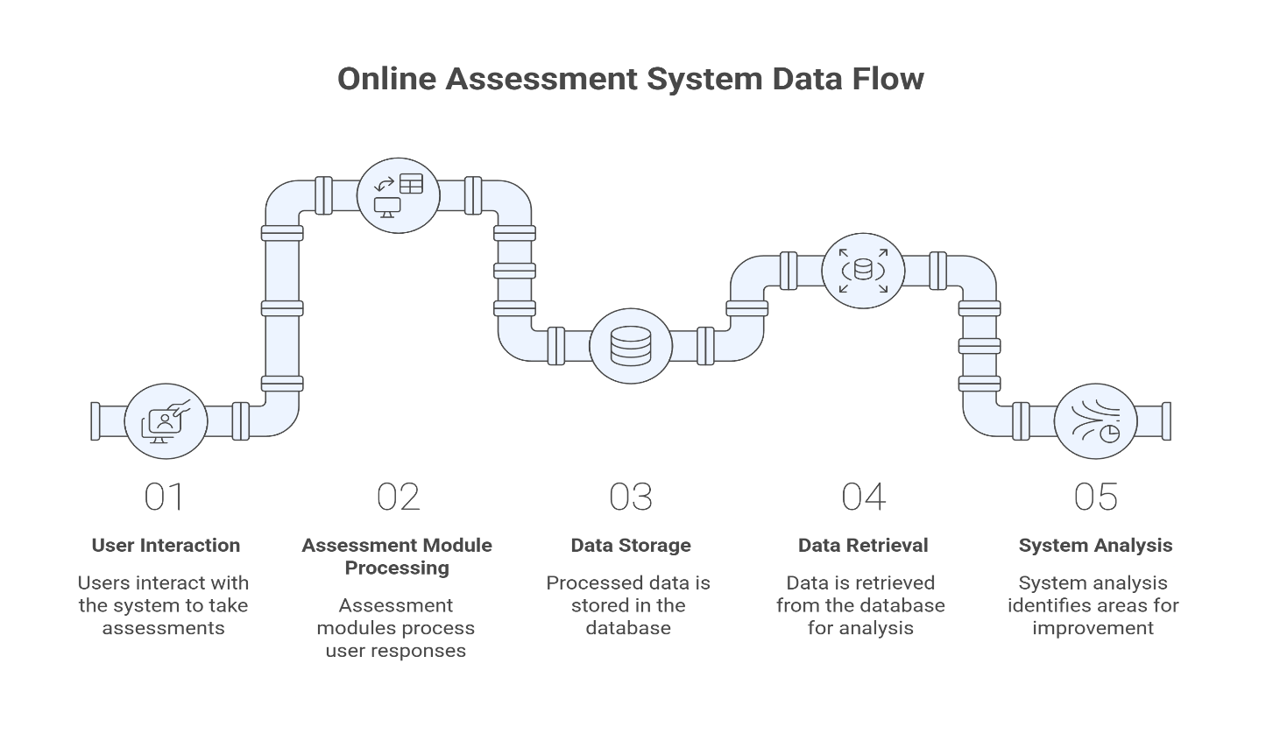

Fig:1

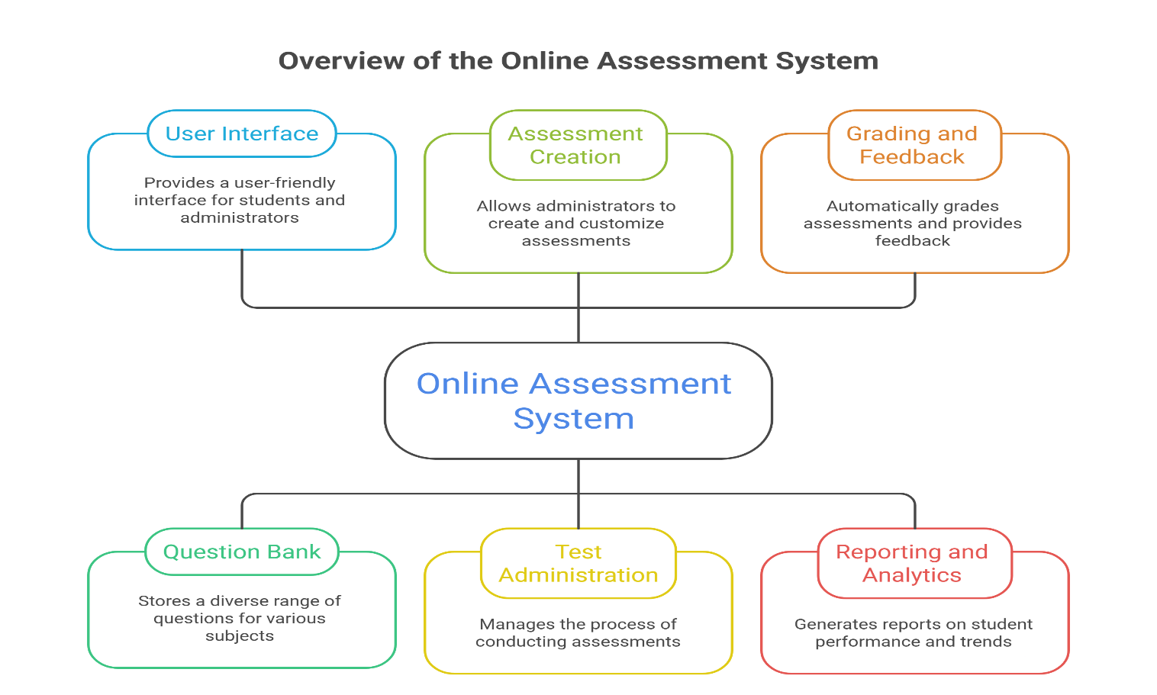

Fig:2

IMPLEMENTATION

4.1 Frontend Implementation
The frontend of the Online Assessment System is developed using HTML, CSS, and JavaScript, following a structured template-based architecture integrated with the Flask framework. This approach ensures clear separation between presentation and backend logic while maintaining simplicity and maintainability. Each functional module such as Login, Registration, Admin Dashboard, Student Dashboard, Exam Interface, and Result Page is implemented as an independent HTML template. This modular design simplifies debugging and allows future enhancements without affecting the entire system.
The frontend templates are rendered dynamically using Flask’s template engine. Data such as exam questions, user information, and results are passed from the backend to the frontend through route handlers. This ensures dynamic content generation without requiring full page reloads for every operation.
JavaScript is used to enhance interactivity and improve user experience. It manages dynamic behaviors such as countdown timers during examinations, navigation between questions, and client-side form validation. The countdown timer ensures that students complete exams within the specified duration, and automatic submission is triggered once the time expires. Client-side validation ensures that mandatory fields are completed before submission, reducing unnecessary server requests.
CSS is used to design a responsive and visually structured interface. Media queries and flexible layouts ensure compatibility across desktops, tablets, and mobile devices. The layout is designed to be clean and intuitive, reducing user confusion during examination attempts.
Flash messaging is implemented to provide real-time notifications. Success, warning, and error messages are displayed after login attempts, exam submissions, or administrative actions. These notifications improve transparency and user interaction.
The frontend structure is organized within the project directory as follows:
- templates folder containing HTML pages
- static folder containing CSS stylesheets and JavaScript files
- structured navigation and consistent UI design across all pages
Overall, the frontend implementation ensures responsiveness, usability, and smooth interaction between the client and server.

4.2 Backend Implementation
The backend of the Online Assessment System is implemented using Python and the Flask framework. Flask provides a lightweight yet powerful environment for building web applications, making it suitable for developing structured academic systems. The backend handles routing, authentication, session management, business logic, database communication, and automatic result processing.
The main application file initializes the Flask application, configures database connections, and defines all application routes. Each route corresponds to a specific system functionality such as user registration, login authentication, exam creation, question management, exam attempt, answer submission, and result display.

The backend follows a modular architecture consisting of:
- Application Layer responsible for routing and request handling
- Business Logic Layer responsible for evaluation and validation
- Database Layer responsible for data storage and retrieval
- Authentication Layer responsible for session control and access restriction
The routing mechanism processes incoming HTTP requests and maps them to appropriate functions. Each route validates input data before processing to ensure system integrity.
The business logic layer ensures that:
- Exams are linked correctly to instructors or administrators
- Questions are associated with specific exams
- Student responses are evaluated accurately
- Duplicate exam entries are prevented
- Scores are calculated correctly
The database layer interacts with PostgreSQL to perform CRUD operations. SQL queries or ORM-based operations are used to retrieve and store data efficiently.

4.3 Authentication and Session Management
Security is implemented using session-based authentication in Flask. When a user submits login credentials, the backend verifies the credentials by comparing the entered password with the securely hashed password stored in the PostgreSQL database. If authentication is successful, a secure session is created.
The session stores essential user information such as user ID and role. This session data is used to control access to protected routes. Unauthorized users attempting to access restricted pages are redirected to the login page.
Passwords are encrypted using secure hashing algorithms before being stored in the database. This ensures that sensitive information is never stored in plain text. Logout functionality clears session data, preventing unauthorized reuse of active sessions.
If unauthorized access is detected, the system returns appropriate error responses and prevents access to protected content.

4.4 Exam Processing and Evaluation
When a student starts an examination, the backend retrieves all associated questions from PostgreSQL and renders them dynamically on the exam page. A JavaScript-based timer begins tracking the examination duration.
Upon submission or when the timer expires, the selected answers are sent to the backend. The evaluation logic compares submitted answers with the correct answers stored in the database. The total score is calculated based on correct responses and stored in the results table.
The result calculation follows the formula:
Total Score = Number of Correct Answers × Marks per Question
The evaluated result is displayed instantly to the student. This automated evaluation mechanism ensures real-time result generation and eliminates manual grading errors.

4.5 Notification and Result Handling System
The system implements notification mechanisms using Flask flash messages. Users receive confirmation messages for successful operations such as login, exam submission, or exam creation. Error messages are displayed for invalid credentials or incomplete forms.
Result data is stored in PostgreSQL and can be retrieved for performance tracking. Students can view their past results, and administrators can monitor examination performance statistics.
All result processing is handled at the backend level to ensure data integrity and prevent manipulation from the client side.

4.6 Database Connectivity and Configuration
The application connects to PostgreSQL using appropriate database connectors configured within the Flask application. Database configuration includes:
- Database name
- Username
- Password
- Host and port
- Secret key configuration
These settings are defined within the Flask configuration file. PostgreSQL ensures data consistency using primary keys, foreign keys, and constraints.
Efficient indexing is applied to frequently queried fields such as user ID and exam ID to improve performance. Proper configuration ensures stable database connectivity even under concurrent usage.

4.7 Exception Handling and Logging
Exception handling mechanisms are implemented to manage errors gracefully. If invalid credentials are entered or a requested resource is not found, the system displays appropriate error messages instead of crashing.
Try-except blocks are used to handle database errors and unexpected runtime issues. Logging mechanisms are implemented to track user authentication attempts, exam submissions, and system errors. Logging assists in debugging and monitoring system activity.

4.8 Deployment Considerations
The Online Assessment System can be deployed on local servers or cloud platforms. The Flask application can be hosted using production servers such as Gunicorn. PostgreSQL can be deployed locally or on managed cloud database services.
Environment variables can be configured to securely store database credentials and secret keys. The integrated frontend and backend structure simplifies deployment and reduces configuration complexity.

Implementation Summary
The implementation of the Online Assessment System integrates frontend technologies such as HTML, CSS, and JavaScript with a secure Flask backend supported by PostgreSQL. The modular architecture ensures maintainability and scalability. Automated evaluation, secure session management, structured database storage, and responsive interface design collectively contribute to a reliable and efficient online examination platform. Security, performance optimization, and data integrity are prioritized throughout the development process.

CODE
FRONTEND
Dashboard.html

{% extends "base.html" %}
{% block title %}Admin Dashboard{% endblock %}

{% block content %}
<div class="dashboard-container">

<!-- STATS -->
<div class="stats-grid">
<div class="stat-card">
<h3>{{ exams|length }}</h3>
<p>Total Exams</p>
</div>

<div class="stat-card">
<h3>{{ stats.total_students }}</h3>
<p>Total Students</p>

<a href="{{ url_for('admin_students') }}" class="view-link">
View Students →
</a>
</div>

<div class="stat-card">
<h3>{{ stats.total_results }}</h3>
<p>Total Results</p>
</div>
</div>

<!-- HEADER -->
<div class="dashboard-header">
<div>
<h2>Admin Dashboard</h2>

<!-- MANAGER ID -->
<p style="margin-top:6px;color:#ccc;font-size:14px;">
<strong>Manager ID:</strong>
<span style="color:#4ade80;font-weight:600;">
{{ manager_id }}
</span>
</p>
</div>

<div>
<a href="{{ url_for('admin_results') }}" class="btn small-btn">
View Results
</a>
<a href="{{ url_for('create_exam') }}" class="btn create-btn">
+ Create New Exam
</a>
</div>
</div>

<!-- TABLE -->
<div class="table-card">
<table>
<thead>
<tr>
<th>Exam Name</th>
<th>Notes</th>
<th style="width:260px;">Actions</th>
</tr>
</thead>
<tbody>
{% for exam in exams %}
<tr>
<td>
{{ exam.title }}<br>
<small>Exam ID: {{ exam.id }}</small>
</td>
<td>
{% if exam.notes_file %}
<a href="{{ url_for('static', filename='uploads/' + exam.notes_file) }}" class="btn small-btn"
target="_blank">
View PDF
</a>

<form action="{{ url_for('upload_notes', exam_id=exam.id) }}" method="POST"
enctype="multipart/form-data" style="display:inline;">
<input type="file" name="notes" accept="application/pdf" required>
<button class="btn small-btn">Replace</button>
</form>

<form action="{{ url_for('delete_notes', exam_id=exam.id) }}" method="POST"
style="display:inline;">
<button class="btn small-btn danger">Delete</button>
</form>
{% else %}
<form action="{{ url_for('upload_notes', exam_id=exam.id) }}" method="POST"
enctype="multipart/form-data">
<input type="file" name="notes" accept="application/pdf" required>
<button class="btn small-btn">Upload</button>
</form>
{% endif %}
</td>

<td>
<a href="{{ url_for('add_question', exam_id=exam.id) }}" class="btn small-btn">
Add Questions
</a>

<a href="{{ url_for('edit_exam', exam_id=exam.id) }}" class="btn small-btn">
Edit
</a>

<form action="{{ url_for('delete_exam', exam_id=exam.id) }}" method="POST"
style="display:inline;" onsubmit="return confirm('Delete this exam?');">
<button class="btn small-btn danger">
Delete
</button>
</form>
</td>
</tr>
{% else %}
<tr>
<td colspan="2" style="text-align:center;">
No exams created
</td>
</tr>
{% endfor %}
</tbody>
</table>
</div>

</div>
{% endblock %}

Login.html
{% extends "base.html" %}
{% block title %}Login{% endblock %}

{% block content %}
<div class="card">
<h2>User Login</h2>

<form method="POST">
<label>Email</label>
<input type="email" name="email" required>

<label>Password</label>
<input type="password" name="password" required>

<button type="submit">Login</button>
</form>

<p class="link">
New user? <a href="{{ url_for('register') }}">Register here</a>
</p>
</div>
{% endblock %}

BACKEND – Config

from werkzeug.utils import secure_filename
import os
import uuid
from flask import Flask, render_template, request, redirect, url_for, flash, session, jsonify
from werkzeug.security import generate_password_hash, check_password_hash
import psycopg2
from psycopg2.extras import RealDictCursor
from datetime import datetime
import google.generativeai as genai
from dotenv import load_dotenv
import os

load_dotenv()
genai.configure(api_key=os.getenv("GEMINI_API_KEY"))

app = Flask(__name__)
app.secret_key = os.environ.get('FLASK_SECRET', 'exam-secret')

BASE_DIR = os.path.abspath(os.path.dirname(__file__))
UPLOAD_FOLDER = os.path.join(BASE_DIR, "static", "uploads")
os.makedirs(UPLOAD_FOLDER, exist_ok=True)

app.config["UPLOAD_FOLDER"] = UPLOAD_FOLDER

ALLOWED_EXTENSIONS = {'pdf'}

app.config['UPLOAD_FOLDER'] = UPLOAD_FOLDER

def allowed_file(filename):
return '.' in filename and filename.rsplit('.', 1)[1].lower() in ALLOWED_EXTENSIONS

# ---------------- POSTGRES CONFIG ----------------
DB_HOST = os.environ.get('DB_HOST', 'localhost')
DB_NAME = os.environ.get('DB_NAME', 'online')
DB_USER = os.environ.get('DB_USER', 'postgres')
DB_PASS = os.environ.get('DB_PASS', 'Bapun@123')
DB_PORT = os.environ.get('DB_PORT', '5432')

def get_db_conn():
return psycopg2.connect(
host=DB_HOST,
database=DB_NAME,
user=DB_USER,
password=DB_PASS,
port=DB_POR
# ---------------- AUTH CHECK ----------------
def login_required(role=None):
def wrapper(fn):
def decorated(*args, **kwargs):
if not session.get('user'):
flash("Please login", "error")
return redirect(url_for('login'))
if role and session['user']['role'] != role:
flash("Unauthorized access", "error")
return redirect(url_for('login'))
return fn(*args, **kwargs)
decorated.__name__ = fn.__name__
return decorated
return wrapper

# ---------------- LOGIN ----------------
@app.route('/', methods=['GET', 'POST'])
@app.route('/login', methods=['GET', 'POST'])
def login():
if request.method == 'POST':
email = request.form['email'].strip().lower()
password = request.form['password'].strip()

conn = get_db_conn()
cur = conn.cursor(cursor_factory=RealDictCursor)
cur.execute("SELECT * FROM users WHERE email=%s", (email,))
user = cur.fetchone()
cur.close()
conn.close()

if user and check_password_hash(user['password'], password):
session['user'] = user
return redirect(url_for(f"{user['role']}_dashboard"))

flash("Invalid email or password", "error")

return render_template('login.html')

# ---------------- REGISTER ----------------
@app.route('/register', methods=['GET', 'POST'])
def register():
if request.method == 'POST':
username = request.form['username'].strip()
email = request.form['email'].strip().lower()
password = generate_password_hash(request.form['password'].strip())
role = request.form['role']

conn = get_db_conn()
cur = conn.cursor(cursor_factory=RealDictCursor)

# 🔥 Check if email already exists
cur.execute("SELECT id FROM users WHERE email=%s", (email,))
if cur.fetchone():
cur.close()
conn.close()
flash("Email already registered. Please login.", "error")
return redirect(url_for('register'))

manager_id = None
if role == 'admin':
manager_id = "ADM-" + uuid.uuid4().hex[:6].upper()

if role == 'student':
manager_id = request.form['manager_id'].strip()
cur.execute(
"SELECT id FROM users WHERE role='admin' AND manager_id=%s",
(manager_id,)
)
if not cur.fetchone():
cur.close()
conn.close()
flash("Invalid Manager ID", "error")
return redirect(url_for('register'))

try:
cur.execute("""
INSERT INTO users (username, email, password, role, manager_id)
VALUES (%s, %s, %s, %s, %s)
""", (username, email, password, role, manager_id))
conn.commit()
flash("Registration successful. Please login.", "success")
return redirect(url_for('login'))
except Exception:
conn.rollback()
flash("Something went wrong. Try again.", "error")
finally:
cur.close()
conn.close()

return render_template('register.html')

# ---------------- ADMIN DASHBOARD ----------------
@app.route('/admin')
@login_required(role='admin')
def admin_dashboard():
user = session['user']
conn = get_db_conn()
cur = conn.cursor(cursor_factory=RealDictCursor)

cur.execute("SELECT * FROM exams WHERE manager_id=%s", (user['manager_id'],))
exams = cur.fetchall()

cur.execute("""
SELECT COUNT(*) FROM users
WHERE role='student' AND manager_id=%s
""", (user['manager_id'],))
total_students = cur.fetchone()['count']

cur.execute("""
SELECT COUNT(*) FROM results WHERE manager_id=%s
""", (user['manager_id'],))
total_results = cur.fetchone()['count']

cur.close()
conn.close()

stats = {
"total_exams": len(exams),
"total_students": total_students,
"total_results": total_results
}

return render_template(
'admin_dashboard.html',
exams=exams,
stats=stats,
manager_id=user['manager_id']
)

# ---------------- VIEW STUDENTS ----------------
@app.route('/admin/students')
@login_required(role='admin')
def admin_students():
user = session['user']

conn = get_db_conn()
cur = conn.cursor(cursor_factory=RealDictCursor)

cur.execute("""
SELECT username, email, manager_id
FROM users
WHERE role='student' AND manager_id=%s
ORDER BY username
""", (user['manager_id'],))

students = cur.fetchall()
cur.close()
conn.close()

return render_template(
'admin_students.html',
students=students,
manager_id=user['manager_id']
)

@app.route('/admin/results')
@login_required(role='admin')
def admin_results():
user = session['user']

conn = get_db_conn()
cur = conn.cursor(cursor_factory=RealDictCursor)

cur.execute("""
SELECT * FROM results
WHERE manager_id = %s
ORDER BY id DESC
""", (user['manager_id'],))

results = cur.fetchall()
cur.close()
conn.close()

return render_template('admin_results.html', results=results)

@app.route('/upload_notes/<int:exam_id>', methods=['POST'])
@login_required(role='admin')
def upload_notes(exam_id):
user = session['user']
file = request.files.get('notes')

if not file or not allowed_file(file.filename):
flash("Only PDF files allowed", "error")
return redirect(url_for('admin_dashboard'))

filename = secure_filename(f"{exam_id}_{file.filename}")
filepath = os.path.join(app.config['UPLOAD_FOLDER'], filename)
file.save(filepath)
conn = get_db_conn()
cur = conn.cursor()
cur.execute("""
UPDATE exams
SET notes_file=%s
WHERE id=%s AND manager_id=%s
""", (filename, exam_id, user['manager_id']))
conn.commit()
cur.close()
conn.close()

flash("Notes uploaded successfully", "success")
return redirect(url_for('admin_dashboard'))

@app.route('/delete_notes/<int:exam_id>', methods=['POST'])
@login_required(role='admin')
def delete_notes(exam_id):
user = session['user']

conn = get_db_conn()
cur = conn.cursor(cursor_factory=RealDictCursor)
cur.execute("""
SELECT notes_file FROM exams
WHERE id=%s AND manager_id=%s
""", (exam_id, user['manager_id']))
exam = cur.fetchone()

if exam and exam['notes_file']:
path = os.path.join(app.config['UPLOAD_FOLDER'], exam['notes_file'])
if os.path.exists(path):
os.remove(path)

cur.execute("""
UPDATE exams SET notes_file=NULL
WHERE id=%s AND manager_id=%s
""", (exam_id, user['manager_id']))
conn.commit()

cur.close()
conn.close()

flash("Notes deleted", "success")
return redirect(url_for('admin_dashboard'))

# ---------------- CREATE EXAM ----------------
@app.route('/create_exam', methods=['GET', 'POST'])
@login_required(role='admin')
def create_exam():
if request.method == 'POST':
title = request.form['title'].strip()
start_time = request.form.get('start_time') or None
end_time = request.form.get('end_time') or None
duration = request.form.get('duration_minutes')

user = session['user']

conn = get_db_conn()
cur = conn.cursor()

cur.execute("""
INSERT INTO exams (title, manager_id, start_time, end_time, duration_minutes)
VALUES (%s, %s, %s, %s, %s)
""", (
title,
user['manager_id'],
start_time,
end_time,
duration
))

conn.commit()
cur.close()
conn.close()

flash("Exam created successfully", "success")
return redirect(url_for('admin_dashboard'))

return render_template('create_exam.html')

# ---------------- ADD QUESTION ----------------
@app.route('/add_question/<int:exam_id>', methods=['GET', 'POST'])
@login_required(role='admin')
def add_question(exam_id):
user = session['user']
conn = get_db_conn()
cur = conn.cursor(cursor_factory=RealDictCursor)

# 🚫 Block editing if exam already started
cur.execute("""
SELECT start_time FROM exams
WHERE id=%s AND manager_id=%s
""", (exam_id, user['manager_id']))
exam = cur.fetchone()

if exam and exam['start_time'] and exam['start_time'] <= datetime.now():
flash("Exam already started. Cannot modify questions.", "error")
return redirect(url_for('admin_dashboard'))

if request.method == 'POST':
# Delete old questions (edit mode)
cur.execute("DELETE FROM questions WHERE exam_id=%s", (exam_id,))

questions = request.form.getlist('question[]')
option1s = request.form.getlist('option1[]')
option2s = request.form.getlist('option2[]')
option3s = request.form.getlist('option3[]')
option4s = request.form.getlist('option4[]')
corrects = request.form.getlist('correct[]')

for i in range(len(questions)):
cur.execute("""
INSERT INTO questions
(exam_id, question, option1, option2, option3, option4, correct)
VALUES (%s,%s,%s,%s,%s,%s,%s)
""", (
exam_id,
questions[i],
option1s[i],
option2s[i],
option3s[i],
option4s[i],
corrects[i]
))

conn.commit()
cur.close()
conn.close()

flash("Questions saved successfully", "success")
return redirect(url_for('admin_dashboard'))

# 🔥 Load existing questions
cur.execute("SELECT * FROM questions WHERE exam_id=%s", (exam_id,))
questions = cur.fetchall()

cur.close()
conn.close()

return render_template(
'add_question.html',
exam_id=exam_id,
questions=questions
)

@app.route('/generate_questions_ai/<int:exam_id>', methods=['POST'])
@login_required(role='admin')
def generate_questions_ai(exam_id):
user = session['user']
conn = get_db_conn()
cur = conn.cursor(cursor_factory=RealDictCursor)

# 1️⃣ Fetch exam + PDF (STRICT: only this exam ID)
cur.execute("""
SELECT notes_file, title
FROM exams
WHERE id=%s AND manager_id=%s
""", (exam_id, user['manager_id']))
exam = cur.fetchone()

if not exam or not exam['notes_file']:
cur.close()
conn.close()
return jsonify({
"error": "Upload notes before generating questions"
}), 400

pdf_path = os.path.join(app.config['UPLOAD_FOLDER'], exam['notes_file'])

if not os.path.exists(pdf_path):
cur.close()
conn.close()
return jsonify({"error": "Notes file not found"}), 404

# 2️⃣ Extract PDF text
import fitz # PyMuPDF
text = ""
doc = fitz.open(pdf_path)
for page in doc:
text += page.get_text()
doc.close()

if not text.strip():
return jsonify({"error": "PDF has no readable text"}), 400

# 3️⃣ Gemini prompt (strict format)
prompt = f"""
You are an exam question generator.

From the content below, generate EXACTLY 10 multiple-choice questions.

Each question must include:
- Question
- Option A
- Option B
- Option C
- Option D
- Correct option (A/B/C/D)

FORMAT STRICTLY LIKE THIS (NO EXTRA TEXT):

Q1. Question text
A. Option text
B. Option text
C. Option text
D. Option text
Correct: A

CONTENT:
{text[:12000]}
"""

try:
# ✅ USE AVAILABLE MODEL
model = genai.GenerativeModel("models/gemini-2.5-flash")
response = model.generate_content(prompt)

ai_text = response.text.strip()

if not ai_text:
raise Exception("Empty response from AI")

except Exception as e:
return jsonify({
"error": f"AI generation failed: {str(e)}"
}), 500

cur.close()
conn.close()

return jsonify({
"questions": ai_text
})

# ---------------- EDIT EXAM ----------------
@app.route('/edit_exam/<int:exam_id>', methods=['GET', 'POST'])
@login_required(role='admin')
def edit_exam(exam_id):
user = session['user']
conn = get_db_conn()
cur = conn.cursor(cursor_factory=RealDictCursor)

cur.execute("""
SELECT * FROM exams
WHERE id=%s AND manager_id=%s
""", (exam_id, user['manager_id']))
exam = cur.fetchone()

if not exam:
cur.close()
conn.close()
flash("Exam not found or unauthorized", "error")
return redirect(url_for('admin_dashboard'))

if request.method == 'POST':
title = request.form['title'].strip()
start_time = request.form.get('start_time') or None
end_time = request.form.get('end_time') or None
duration = request.form.get('duration_minutes')

cur.execute("""
UPDATE exams
SET title=%s,
start_time=%s,
end_time=%s,
duration_minutes=%s
WHERE id=%s AND manager_id=%s
""", (
title,
start_time,
end_time,
duration,
exam_id,
user['manager_id']
))

conn.commit()
cur.close()
conn.close()

flash("Exam updated successfully", "success")
return redirect(url_for('admin_dashboard'))

cur.close()
conn.close()
return render_template('edit_exam.html', exam=exam)

# ---------------- DELETE EXAM ----------------
@app.route('/delete_exam/<int:exam_id>', methods=['POST'])
@login_required(role='admin')
def delete_exam(exam_id):
user = session['user']

conn = get_db_conn()
cur = conn.cursor()

# Ensure exam belongs to this admin
cur.execute("""
DELETE FROM exams
WHERE id = %s AND manager_id = %s
""", (exam_id, user['manager_id']))

conn.commit()
cur.close()
conn.close()

flash("Exam deleted successfully", "success")
return redirect(url_for('admin_dashboard'))

# ---------------- STUDENT DASHBOARD ----------------
@app.route('/student')
@login_required(role='student')
def student_dashboard():
user = session['user']

conn = get_db_conn()
cur = conn.cursor(cursor_factory=RealDictCursor)

# ---------------- FETCH EXAMS ----------------
cur.execute(
"SELECT * FROM exams WHERE manager_id=%s",
(user['manager_id'],)
)
exams = cur.fetchall()

SCREENSHOTS
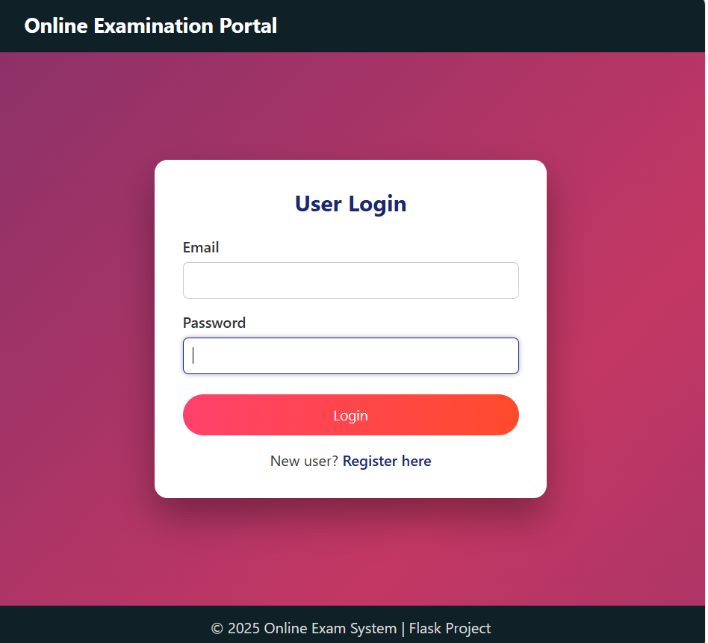
Fig:1.1 Login Page

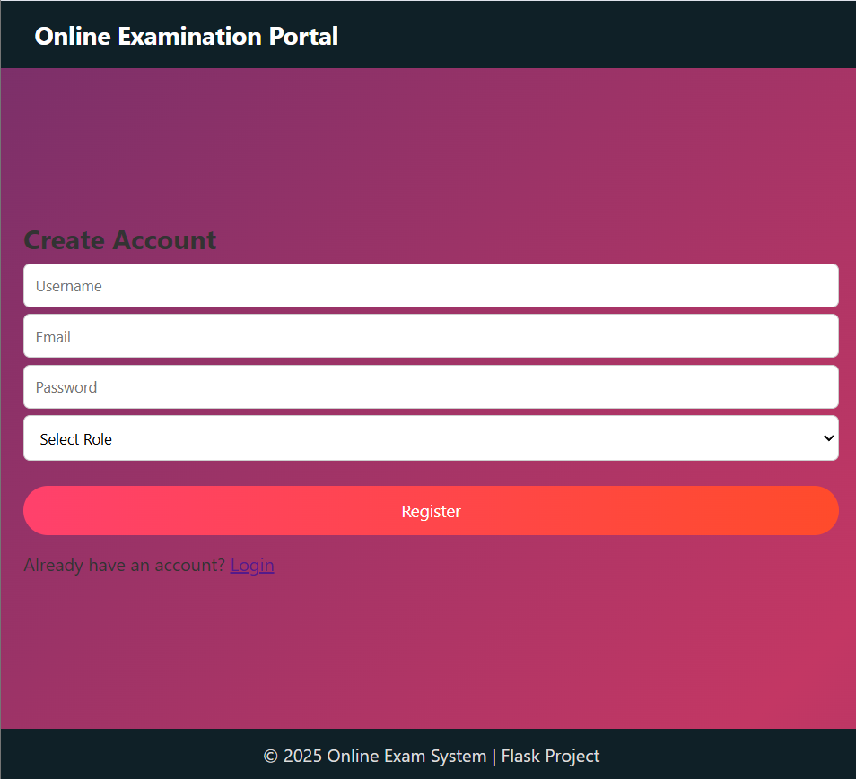
Fig:1.2 Sign up or create user page

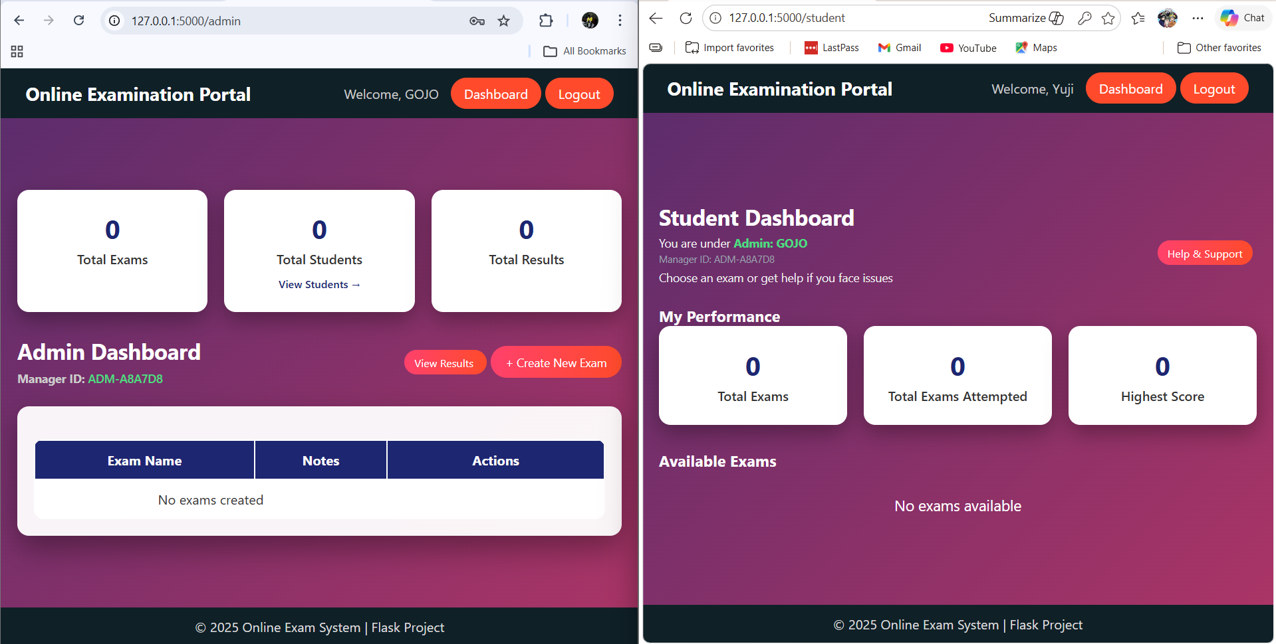
Fig:1.3 Student and Admin Dashboard

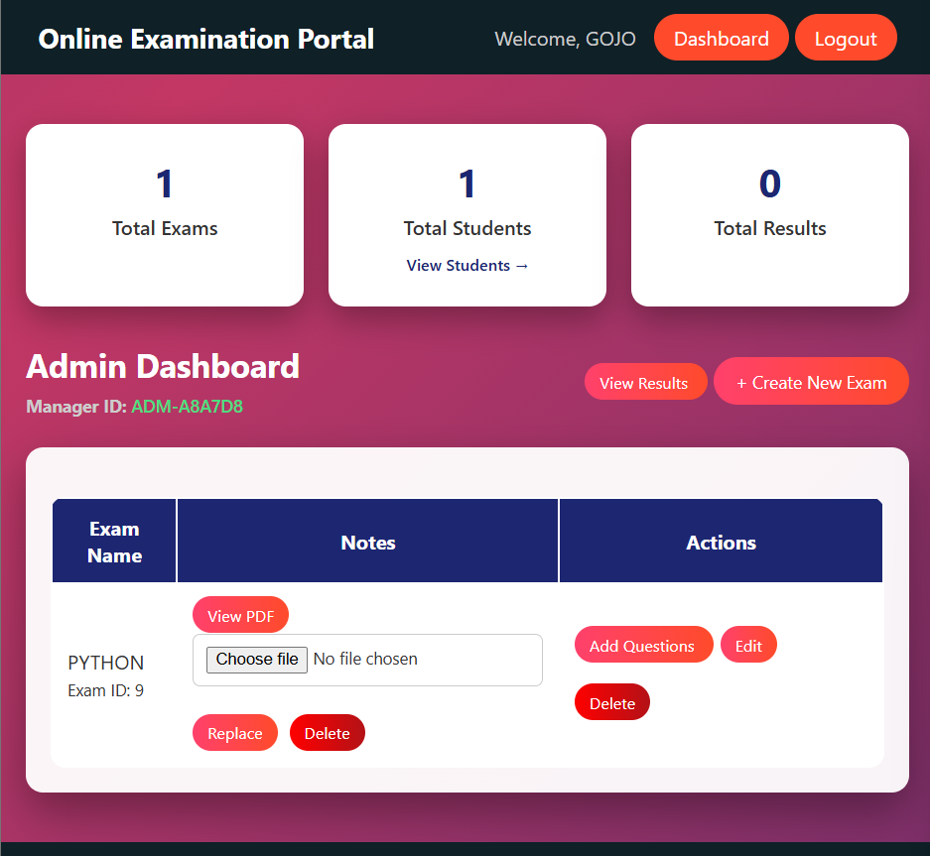
Fig:1.4 Admin Exam Actions

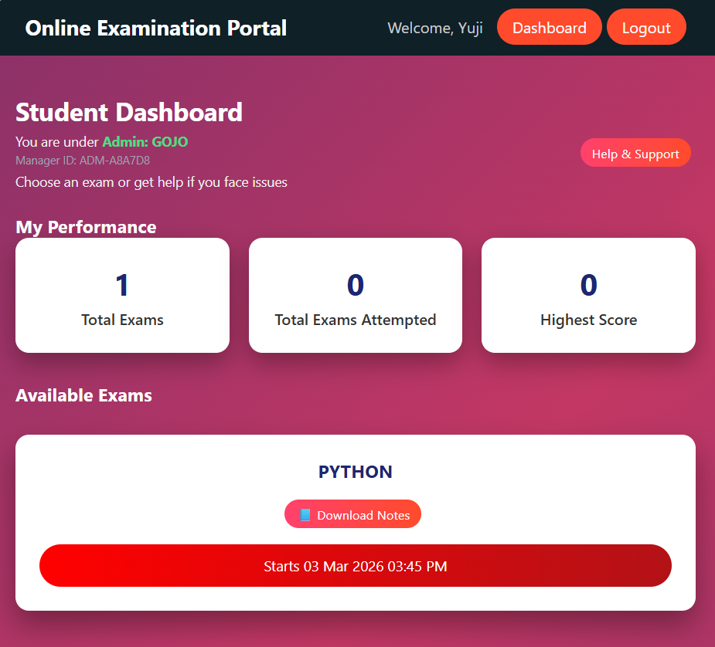
Fig:1.5 Student Exam Schedule

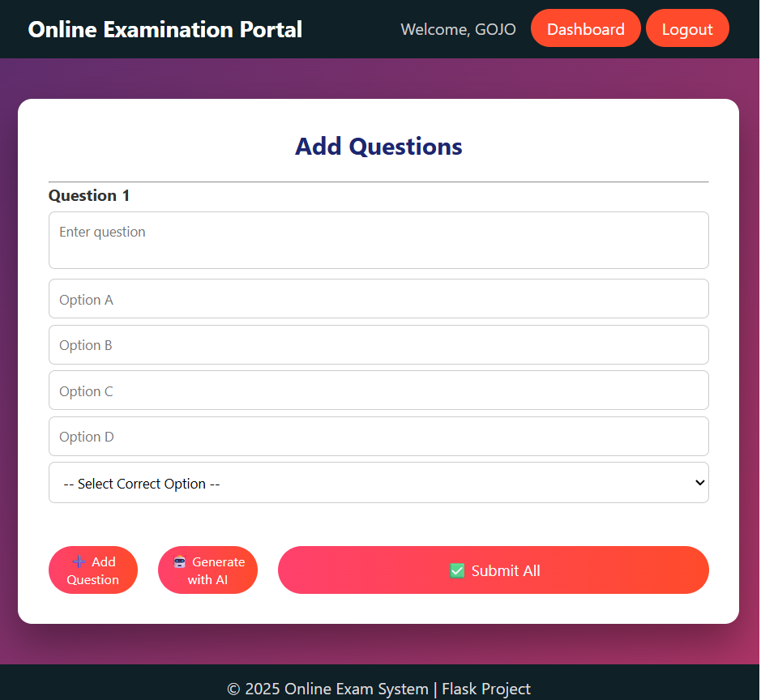

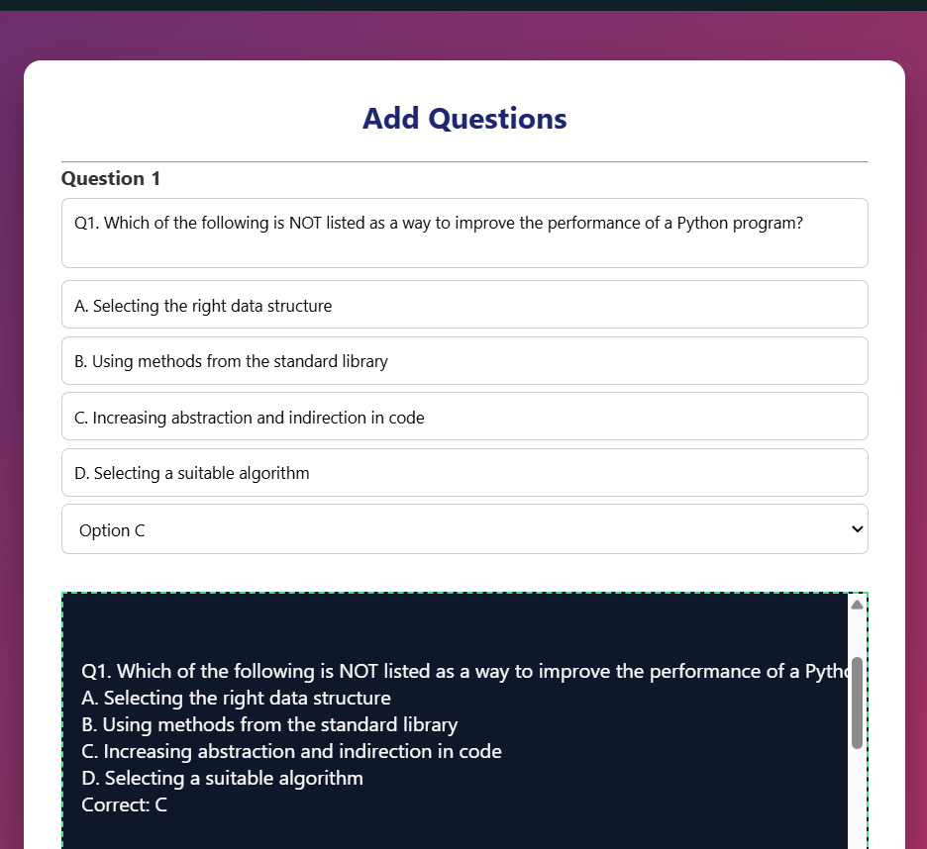
Fig:1.6 Ai generated Question through uploaded PDF

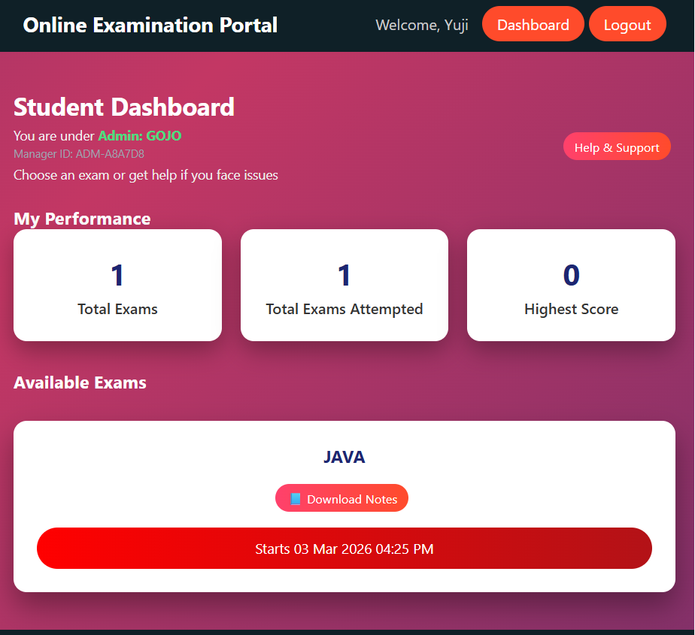

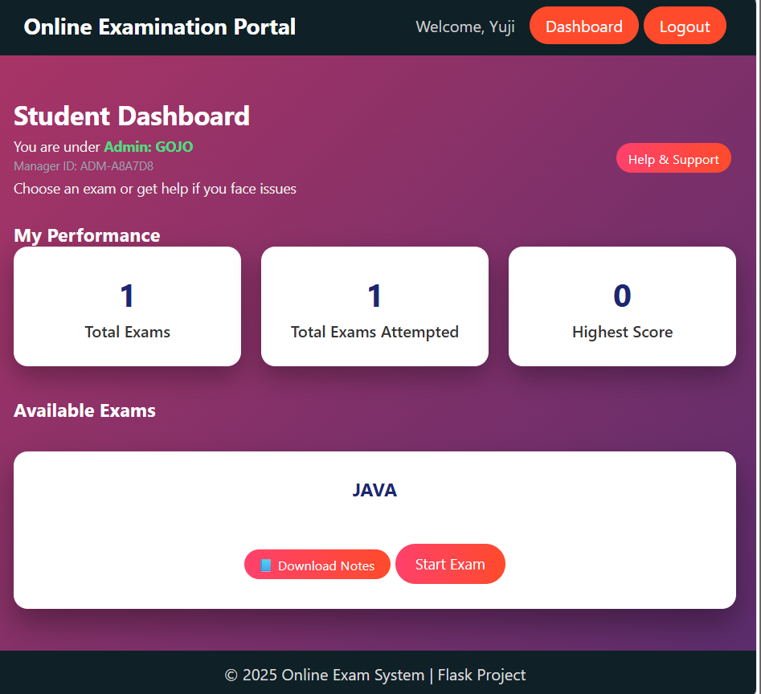

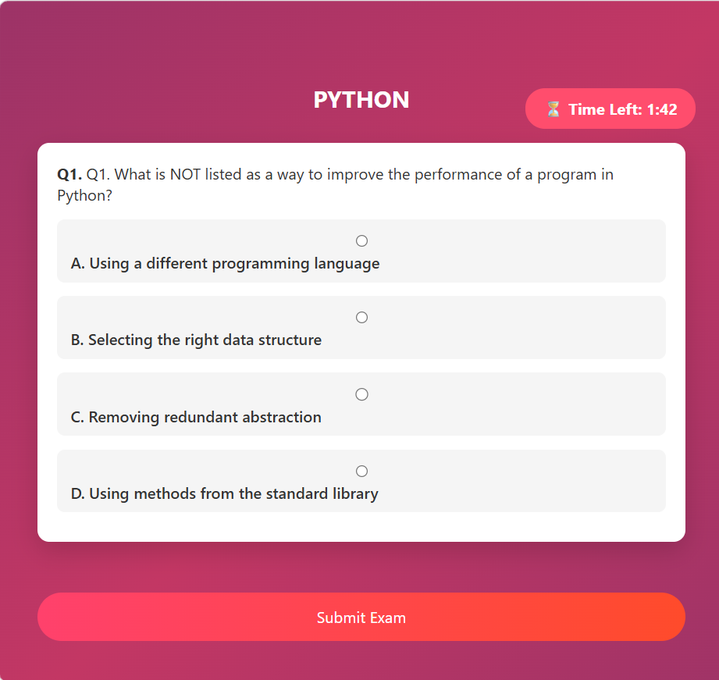
Fig:1.7 Exam starts
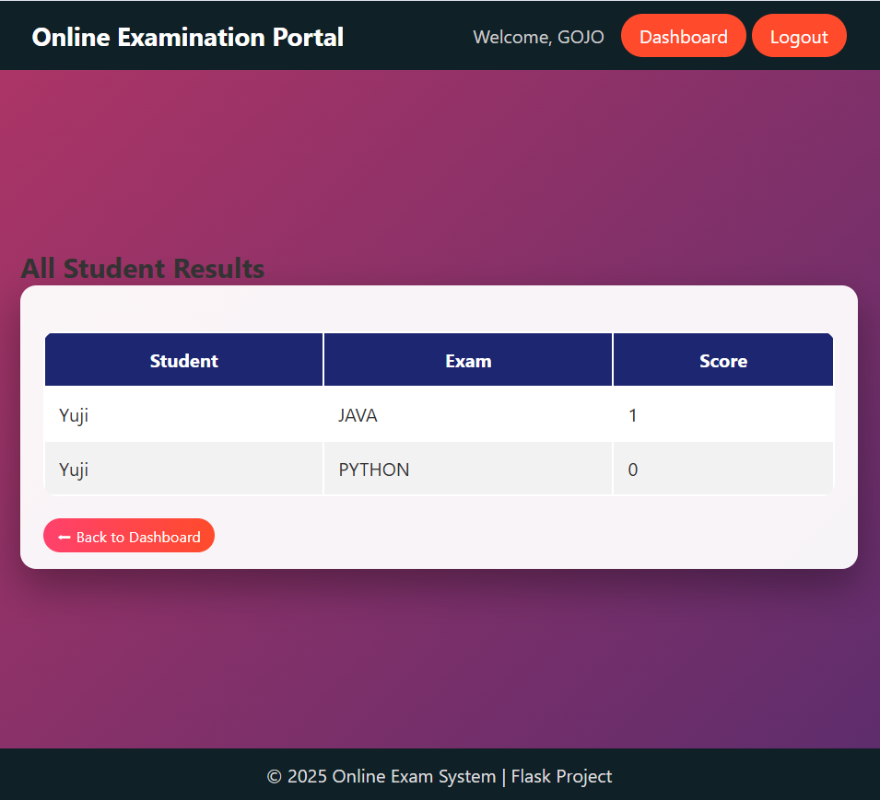
Fig:1.8 Results

CONCLUSION
5.1 Summary
The Online Assessment System successfully delivers a secure, efficient, and user-friendly platform for conducting digital examinations in a structured academic environment. The system addresses the limitations of traditional paper-based examination methods by providing an automated, centralized, and secure assessment solution. Through its structured authentication mechanism, intuitive interface design, and automated result processing features, the system simplifies the process of exam creation, management, evaluation, and result publication.
By integrating Python and Flask for backend development, HTML, CSS, and JavaScript for frontend interaction, and PostgreSQL for reliable data storage, the project demonstrates how modern web technologies can be effectively combined to build scalable and maintainable web applications. The three-tier architectural design ensures clear separation between presentation, application logic, and database layers, making the system easier to manage, debug, and extend in the future.
One of the most significant achievements of the Online Assessment System is its ability to automate the evaluation process. Objective-type questions are evaluated instantly, ensuring accuracy and eliminating manual grading errors. The real-time result generation feature enhances transparency and reduces administrative workload. Secure session-based authentication ensures that user data remains protected and accessible only to authorized individuals.
The project also demonstrates practical implementation of software engineering principles such as modular design, database normalization, structured routing, secure authentication, and proper exception handling. By combining theoretical knowledge with practical development, the Online Assessment System serves as a strong example of applied full-stack web development using Flask.
Overall, the system achieves its primary objective of providing a reliable, scalable, and secure online examination platform. It simplifies assessment management while improving efficiency, accuracy, and academic transparency.

5.2 Achievements of the System
The major achievements of the Online Assessment System include the successful implementation of secure session-based authentication and role-based access control. The system provides automated exam evaluation with instant result generation, reducing manual effort and improving accuracy. It ensures structured storage of data using PostgreSQL with proper referential integrity and normalization. The user interface is responsive and easy to navigate, enhancing overall usability. The modular Flask-based architecture ensures scalability and readiness for future enhancements.
The system fulfills all functional and non-functional requirements identified during the requirement analysis phase, ensuring both security compliance and performance efficiency.

5.3 Limitations of the Current System
Although the Online Assessment System performs effectively within its defined scope, certain limitations remain in the current version. The system currently supports only objective-type questions and does not include subjective answer evaluation. Advanced proctoring mechanisms such as webcam monitoring or AI-based cheating detection are not implemented. The system does not currently support large-scale distributed deployment or multi-institution collaboration features. Additionally, advanced analytical dashboards and graphical performance reports are limited in the current version.
These limitations provide opportunities for future enhancement and expansion.

5.4 Future Enhancements
The Online Assessment System is designed with scalability and modularity in mind, allowing several improvements in future versions. Potential enhancements include the integration of subjective answer evaluation with manual grading support. AI-based proctoring and cheating detection mechanisms can be implemented to enhance examination integrity. Advanced performance analytics and graphical result visualization can be added to improve academic insights.
Future versions may include exporting results in PDF or Excel format, integration with institutional learning management systems, and mobile application development for better accessibility. Cloud-based deployment with auto-scaling capabilities can improve performance under high user traffic. Multi-language support and enhanced accessibility features can broaden system usability.
By incorporating these features, the Online Assessment System can evolve into a comprehensive digital examination management platform.

5.5 Final Statement
In conclusion, the Online Assessment System represents a practical and modern solution to the challenges of traditional examination management. It successfully integrates security, automation, usability, and scalability into a cohesive digital platform. The project highlights the effective application of Python Flask and PostgreSQL in building structured web applications and demonstrates how systematic software engineering practices can result in a reliable and impactful real-world system.
The system lays a strong foundation for further innovation and technological expansion, ensuring adaptability to future academic and technological requirements. Through automation, secure design, and structured data management, the Online Assessment System contributes to improving efficiency, transparency, and reliability in digital education environments.

BIBLIOGRAPHY

• Grinberg, M. (2018). Flask Web Development (2nd ed.). O'Reilly Media.
• Ramalho, L. (2022). Fluent Python (2nd ed.). O'Reilly Media.
• PostgreSQL Global Development Group. (2024). PostgreSQL Documentation. https://www.postgresql.org/docs/
• Pressman, R. S., & Maxim, B. R. (2019). Software Engineering: A Practitioner’s Approach (9th ed.). McGraw-Hill Education.
• Mozilla Developer Network (MDN). (2024). HTML, CSS, and JavaScript Documentation. https://developer.mozilla.org/
• Flask Documentation. (2024). Flask Official Documentation. https://flask.palletsprojects.com/
• Fielding, R. T. (2000). Architectural Styles and the Design of Network-based Software Architectures. University of California, Irvine.
• Richards, M., & Ford, N. (2020). Fundamentals of Software Architecture: An Engineering Approach. O'Reilly Media.
• Fielding, R. T. (2000). Architectural Styles and the Design of Network-Based Software Architectures. Doctoral Dissertation, University of California, Irvine.
• OWASP Foundation. (2024). OWASP Web Security Testing Guide. https://owasp.org/
• Stallings, W. (2017). Cryptography and Network Security: Principles and Practice (7th ed.). Pearson.
• NIST. (2023). Digital Identity Guidelines. National Institute of Standards and Technology.
• Fowler, M. (2002). Patterns of Enterprise Application Architecture. Addison-Wesley Professional.
• Elmasri, R., & Navathe, S. B. (2016). Fundamentals of Database Systems (7th ed.). Pearson.
• Silberschatz, A., Korth, H. F., & Sudarshan, S. (2019). Database System Concepts (7th ed.). McGraw-Hill.
• Date, C. J. (2019). An Introduction to Database Systems (8th ed.). Pearson.
• Gunicorn Documentation. (2024). Gunicorn – Python WSGI HTTP Server. https://gunicorn.org/
• PostgreSQL Tutorial. (2024). PostgreSQL Official Tutorials. https://www.postgresqltutorial.com/

